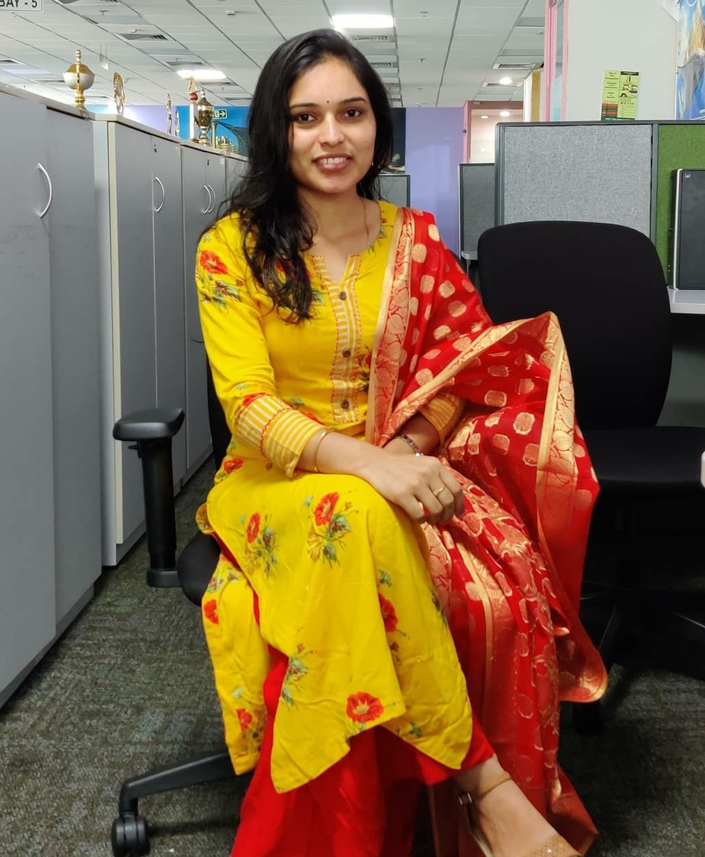 |  |  |  | Jyothi Badavath  Mainframe developer

Profile
A result driven professional with over 7.6 years of experience in Mainframes Development and Operations across different development teams.
Good communication skills and leadership quality and enabling knowledge sharing among the team. Worked in the Retail Domain, financial Domain, and telecommunication mainly on COBOL, JCL, CICS, PL/I, DB2, IMS DB &DC and VSAM

Experience
Application development senior analyst, Accenture, Hyderabad
From Jan, 2019 to till date
- Financing Domain: Working as a developer, Working in all SDLC phase Impact Analysis, Design, Coding, Unit Testing, Implementation
- Retail Domain: as a production supporter, used to analyze customer queries and provide solution to the customers based on the priority of the tickets and fixing the production job abends
- Telecommunication Domain: Worked as system tester and developer, used to prepare reports for integration testing for the developed codes before deploying to production and coding the requirements from scratch and in enhancement requirements
- Maintained on-time rate for developmental deliverables
- Technologies Used: JCL, COBOL, DB2, IMS DB, VSAM, ISPF, PL/I
Technology Analyst, Infosys, Hyderabad
From Sep, 2015 to Jan,2019
- Financial and Retail domain. Worked as a Developer
- Designed and maintained consistent data collection protocols and standards across numerous databases and projects.
- Authored technical requirement documentation to suit business goals and technological limits.
- Cultivated professional working relationships with internal personnel, vendors, and suppliers.
- Communicated project status to stakeholders, authoring reports to provide up-to-date overviews of ongoing progress.
- Technologies used: JCL, COBOL, CICS, DB2, IMS DB, VSAM, ISPF, Clist

Education
- B.tech (Chemical Engineering) from Andhra university, Vizag in the year 2011-2015 with 92.3%

Technical skills
Operating system.: Windows, MVS(Z-OS)
Programming language: IBM Mainframe - COBOL, JCL, CICS, PL1 and CList
Database: COBOL-DB2, COBOL-IMS DB/DC
File Management: VSAM, PS, PDS
Utilities: IEBGENER, IDCAMS, IEFBR14
OLTP: ISPF
Tools: ENDEVOR, FILEAID (MF Utilities), CA Workload and Automation, SPUFI

 |  | Medipally, Hyderabad
 |  | +91 6300498963
 |  | b.jyothi08@gmail.com

